**BIOREACTOR**

*ENGF0001 – Engineering Challenge 2*

*Team Technical Report*  
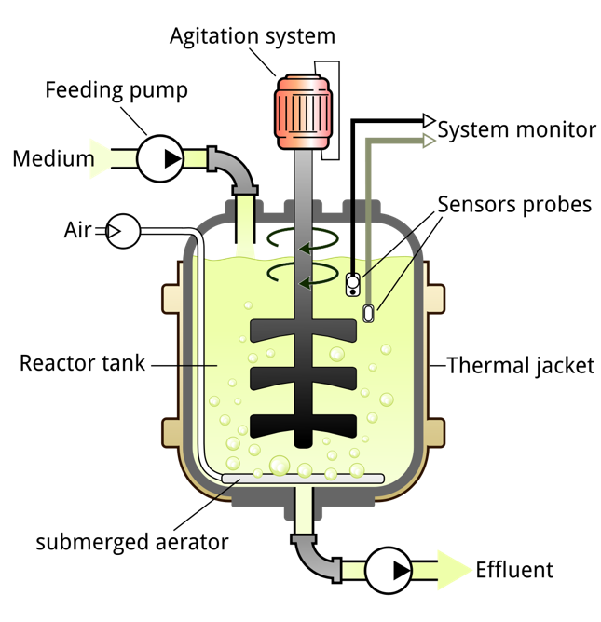

Reference: from wikipedia

**Produced by:**

WENXIN WANG

YANSONG LIU

TENG WANG

ZHIJUN LIN

KAI XU

SAMUEL EMILOLORUN

YIZHI HU

CHOI LAM WONG

GOVIND BALLA

PUMI SUNGAN

YIFAN ZHANG

Challenge 2: Global Health care

EEE-CS Specialist Team Final Report

Authors: Wenxin Wang, Choi Lam Wong, Govind Balla, Kai Xu, Pumi Su-ngan, Samuel Emilolorun, Teng Wang, Yansong Liu, Yifan Zhang, Yizhi Hu, Zhijun Lin

1. Introduction 3
2. Subsystem Descriptions 5
   1. pH 5
      1. pH sensor 5
      2. Pumps 6
      3. Logic and Testing results 6
   2. Temperature 7
      1. Sensor 7
      2. Heater 8
      3. Testing 8
   3. Stirring 9
      1. Motor speed sensor 9
      2. Motor driver 9
      3. Testing and results 9
3. Overall System Integration and Summary 11

3.1 UI 11

3.1.1 Controlling 11

3.1.2 Monitoring 11

3.2 Summary 11

1. Appendices 12
   1. Appendix 1 Temperature overall circuit 12
   2. Appendix 2 Temperature MOSFET 12
   3. Appendix 3 Stirring overall circuit 13
   4. Appendix 4 14
   5. Appendix 5 14
   6. Appendix 6 Prototype 15
2. Reference 16
3. Introduction

**Section Authors:** Wenxin Wang, Yizhi Hu

In Engineer Challenge 2, our task is to work in interdisciplinary teams to design and prototype certain aspects of a Tuberculosis vaccine production facility in Uganda.

We as CSEEE specialist team are requested to work on designing and building a bioreactor control system to ensure the production of Tuberculosis vaccine. The team is divided into four sub-groups: Temperature, pH, Stirring and UI to work individually on sub-systems.

The control system needs to meet several requirements for the production to be carried out successfully. Specifications for subsystems are described below:

1. Inlet water temperature range is 10-20°C. The temperature control system is able to maintain the temperature at a set point in the range 25-35°C to within ±0.5°C of the set point.
2. Required stirring speed range is 500 - 1500 RPM. The stirring control system is able to maintain stirring speed within ±20 RPM
3. pH sensing range is 3-7. The pH control system can maintain pH at optimum 5.
4. All subsystems should log data and provide a user interface for monitoring and set point adjustment.

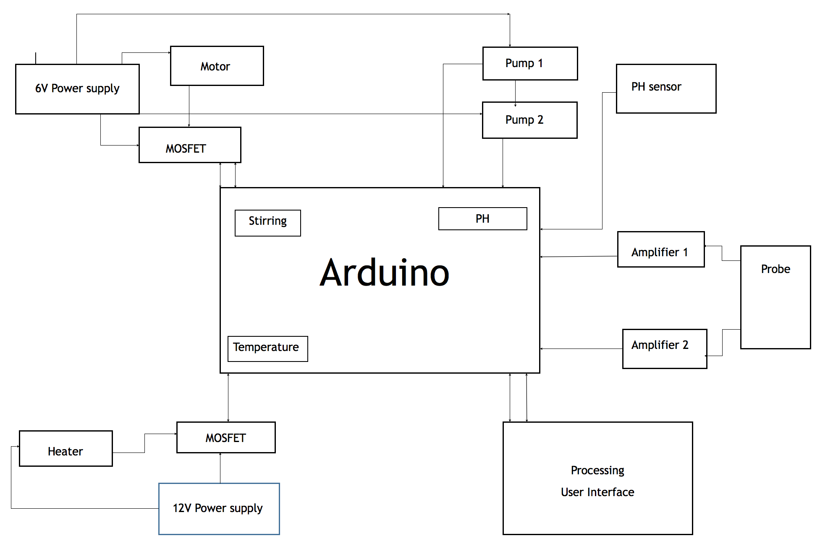 The following digram Figure 1 is our top-level design of this project. We used Arduino as our microcontroller and Processing to create user interface. The components we used include Power supplies, Motor, Heater, pH sensor, Amplifier, probe, pumps and MOSFET. The circuit of each sub-system will be explained in detail in sub-system sections.

*Figure 1: Embedded System used for bioreactor control system*

We have come across several technical problems when designing the project. For heating sub-system, the water would continue to heat up after the heater is being turned off due to the lingering warmth on the heater. For Stirring sub-system, the number of rotations per unit time shown on the monitor is not the same as the value measured by the infra-red gun. Also, at first the speed of the motor is always faster than the given range (500-1500 RPM), we tried to put it in series or in parallel with resistors, but it didn’t work very well. Fortunately, at last, these problems are all solved, the method we used will be mentioned in the following report.

The control system is very important to the overall challenge as it is used to allow for the fermentation of microbes for production of vaccine. All aspects that can have an effect on growing microbes must be taken into consideration, including pH, temperature and stirring speed. These need to be maintained at a specific, stable level so that microbes can work at optimum conditions and not be too slow or denature. Our prototype meets these standards.

Aside from technical aspects, the social and cultural aspects of the TB vaccination plant project also influences our work as engineers. Problems could arise from cultural, safety, ethics and sustainability perspectives. These need to be taken into consideration when planning the project for real.

1. Local cultural stakeholders that may oppose the TB vaccine project or those who have special needs.
2. Risks to the vaccine project posed by the local context, including security risks and medical safety.
3. Ethics involved in the vaccine project and strategies to ensure these are taken into account.
4. Some factors will affect the socio-economic and environmental sustainability of the vaccine production and usage.
5. Subsystem Descriptions
   1. pH

**Section Authors:** Teng Wang, Pumi Su-ngan, Govind Balla, Samuel Emilolorun

The pH sub-system is composed of a pH probe sensor and two pumps. This system uses a probe to detect the potential difference between two electrodes, which is then being processed by the micro-controller to calculate pH value. Pumps are controlled by an Arduino program to add acid or base to maintain a specific pH value. The overall circuit design is 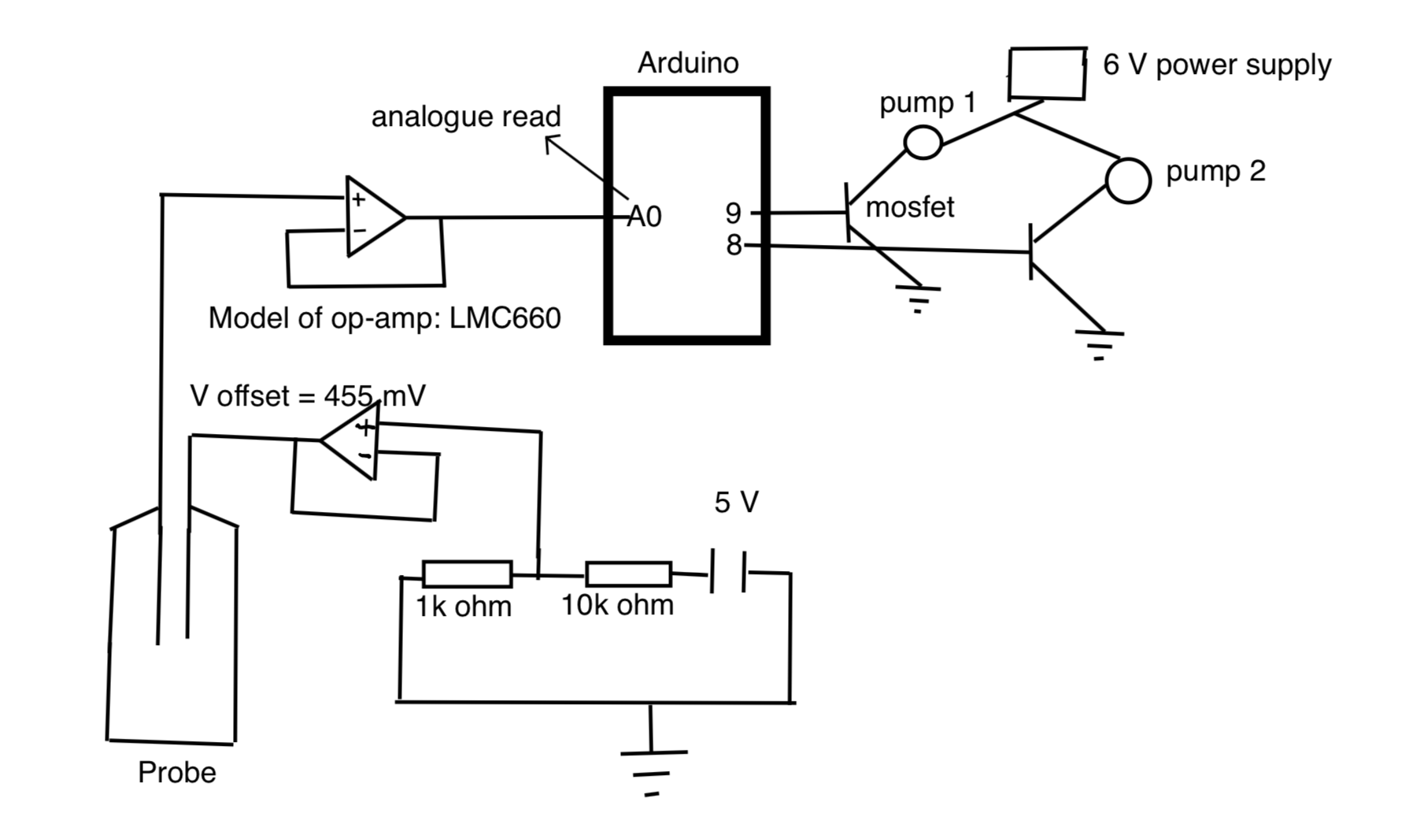shown below.

*Figure 2: pH overall circuit diagram*

* + 1. pH sensor

**Section Authors:** Teng Wang, Govind Balla

pH can be sensed from the potential difference between pH electrode and reference electrode in the probe.

For the supply of reference voltage, we use a constant DC power supply from 5V pin on Arduino.Then the 5V voltage is divided through a potential divider which is comprised of a 10k ohm resistor and a 1k ohm resistor. In this way we get 455 mV for reference voltage which is very similar to that on the data sheet given from the probe producer **[1]**.

However, this voltage should not be sent into the probe directly because the thin glass bulb of probe has a very large resistance ranging from 10M ohm to 1000M ohm, which means even a small current is able to cause a large variation of voltage inside the probe and would produce heat to influence the solution temperature. To avoid this, we have used a unity amplifier which ideally has infinite input impedance to minimize the current going into the probe.

For the amplifier, we chose the model of LMC 660 **[2]** for two reasons. One is that the power supply range for amplifier is between 5 – 15.5 V which allows us to use the 5V power supply from Arduino. The other is that this model has a relatively low input – bias current (2f A) which is very close to the ideal situation. Finally, the output voltage from probe is read by the analogue pin A (0) on Arduino.

* + 1. Pumps

**Section Authors:** Pumi Su-ngan, Samuel Emilolorun

In this part we are aiming to use a low current to monitor a high current pump with MOSFET **[3]** transistors. First, we build two circuits for a 6V battery and a pump respectively. For the lines connecting ground and pump, we substitute a MOSFET which opens and closes the circuit from the Arduino. In this case, two pumps are controlled by two MOSFETs depending on the voltage giving from Arduino. **[4]**

* + 1. Logic and Testing results

**Section Authors:** Teng Wang

The analogue read from A(0) is a digital number in the range of 0-1023, so we need to map it to voltage form by (reading number * 5)/1024. It is converted into pH values by pH = (455mV – output) *F/ (R*T*ln (10)) **[5]** where F and R are constants and T is temperature in kelvin (assume T = 300 k). To allow for some error margin in the voltage inputs due to inaccurate 455mV offset voltage and not constant temperature, we decided, from the testing process, that the software should turn on a pump only when the pH is not in the range of 4.5-5.5. When a pump is on, it pulsates at an interval of 1 second instead of continuous running. We implemented this in code because a continuous working pump might overshoot the required pH range (4.5-5.5) if too much acid/base is added just outside this range, whereas a pulsating pump wouldn’t add too much liquid at once.

After the circuit was built, we did some tests with several solutions with different pH values and the results is shown below. Generally, the detected pH value is around ±0.25 different from the actual pH value, which might be caused by the unstable 455mV reference voltage or varying temperature in the probe. However, such error is acceptable for the normal operation of the subsystem as our requirements is to sense the pH in the range of 3 to 7. Moreover, we have also added a 1 second delay to enable the sensor to get a more stable and accurate value. In practice, the pumps worked properly that when pH was lower than 4.5, the base pump would start pumping and when the pH was higher than 5.5, the acid pump started working.

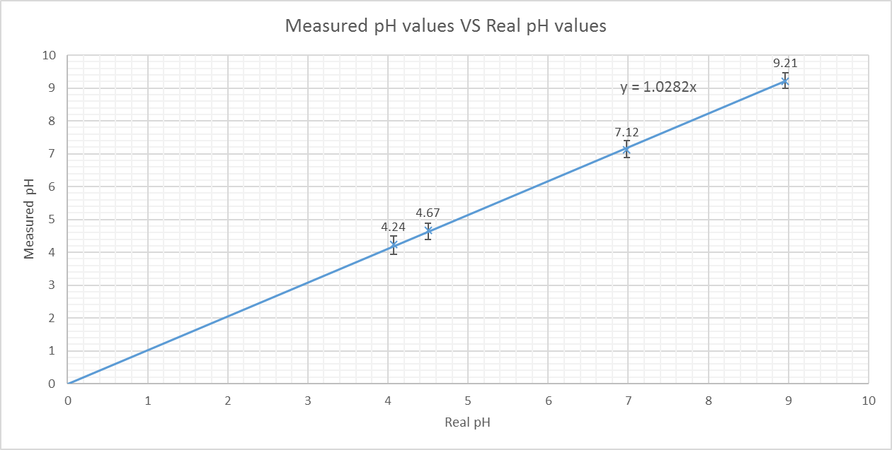

*Figure 3: Measured pH values against real pH values*

* 1. Temperature

**Section Authors:** Zhijun Lin, Kai Xu

The purpose of this part is to control the temperature of the bioreactor. In this subsystem, a sensing part as well as an output part is needed to build the circuit. The overall design is included in ***4.1 Appendix 1 Temperature overall circuit***.

* + 1. Sensor

**Section Authors:** Zhijun Lin, Kai Xu

The system is designed to measure the temperature for the bioreactor by finding the voltage change between the thermistor and resistor. The requirement is to read the temperature within a range of 0 to 0.5 degrees Celsius.

To find the temperature, we need to find the resistance of the thermistor. However, a microcontroller does not have a resistance-meter built in. Instead, it only has a voltage reader known as an analog-digital-converter. So, we can only use voltage to determine the temperature. In order to do that, we connected a resistor of 10k ohm and the thermistor in series and measured the voltage between them by connecting the point between them to the analog input pin. This is to get the voltage reading at that point and the temperature can be calculated. The Arduino pins A1 and 3 are used, connected to the thermistor and the MOSFET gate separately.

A temperature function is being included in the loop function so it will be executed repeatedly. The code is written such that it first calculates the resistance of the thermistor. The resistance of the resistor connected in series has a resistance of 10k Ohm. The formula is R = 10K / (1023 /ADC – 1) where R is the resistance of the thermistor and ADC is the reading of the Arduino pin A1. **[6]**

The temperature is calculated from the resistance of the thermistor. The formula is 1/T = 1/T0 + 1/B ln(R/R0) where T0 is the room temperature, B is the coefficient of the thermistor and R0 is the resistance at room temperature. **[7]** The red line (y=0.98*x+0.94) represents the best-fit line of the calculated value of the temperature between the target range. The black line (y=x) represents the ideal relationship of the actual reading and the calculated value. The error bar represents the maximum uncertainty of the data.

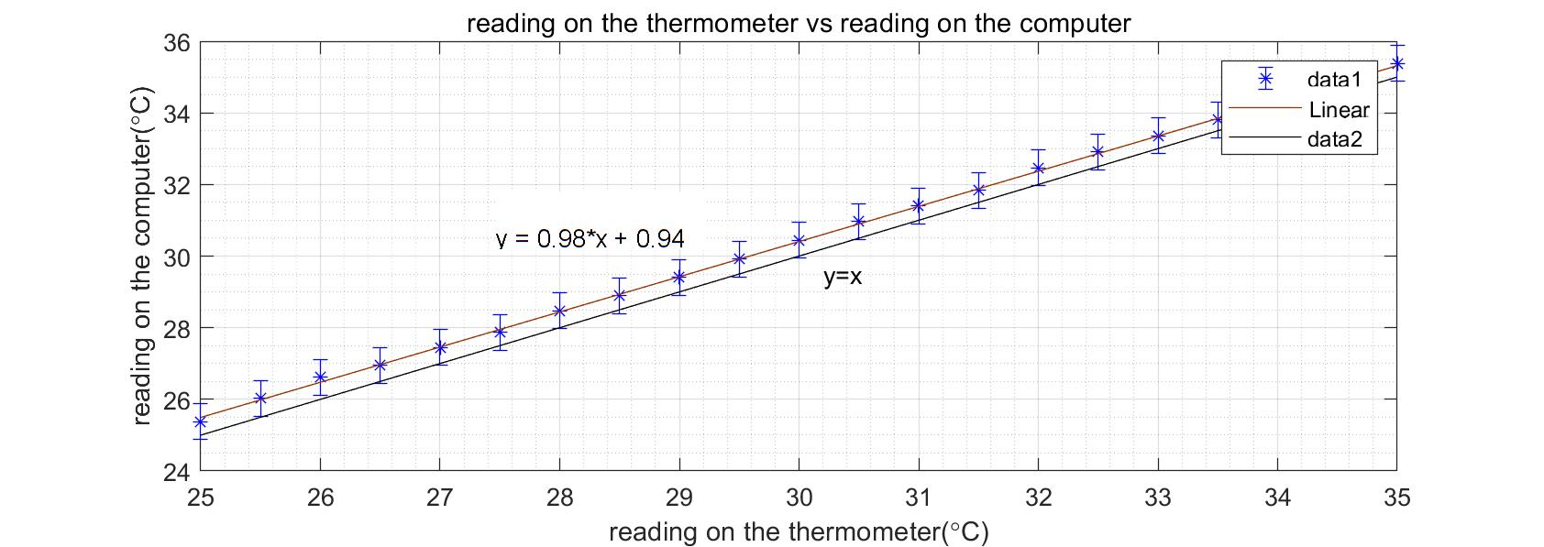

*Figure 4: Temperature readings on thermometer and on computer*

* + 1. Heater

**Section Authors:** Zhijun Lin

The designed circuit includes an output device-heater, as well as a switch-MOSFET. The purpose of this design is to control the operation of the connected heater, in this case, the temperature of the solution can be maintained in an expected range.

The working principle of a MOSFET is included in ***4.1 Appendix 2 Temperature MOSFET***. (Also include reference **[8][9][10]**)

The threshold voltage is the minimum voltage needed to be supplied to the gate to turn on the MOSFET. The drain-source will be connected if there is an appropriate positive voltage (higher that threshold voltage) given to the gate input, which means the component in this circuit can be operated.

* + 1. Testing

**Section Authors:** Zhijun Lin, Kai Xu

In order to make sure every single part of the whole circuit can work properly, we test each component separately. We focus on the heater and MOSFET in particular.

During this process, we disconnect the sensing part in the circuit to ensure that only the operation of the heater is tested. After the gate-source threshold voltage is found out (around 2-2.5V), we turn on the heater, an appropriate voltage (3.3V) is given by the Arduino to drain of the MOSFET. To turn off the heater, a voltage level below the gate threshold voltage must be supplied to the drain (0V).

An ammeter can be connected in the circuit to test the operation of the heater. If a current is detected by the ammeter, then the heater is operating. If there is no current flowing, the heater is now turned off as the drain-source is not connected due to the insufficient voltage given to the gate.

After we ensure that the specifications can both be met by the sensing part and output part, we combine the whole circuit.

We met several problems during the design process:

* + The heater could not be turned on although an appropriate positive output is given to the gate of MOSFET, this problem is solved by connecting the source of MOSFET to the ground.
  + The water will continue to be heated up after the heater is already turned off because of the lingering warmth on the heater.

To tackle this problem, we tried to make the heater operate with varying power at different temperatures by adding a PWM function on the Arduino.

* + When the defined temperature is 3℃ higher than the actual reading, the PWM on the Arduino is set to be 255, which means the heater is operating with the maximum power.
  + When the temperature difference is between 0~3℃, the PWM can be altered between 0~255, at that time, the heater is working with a low power.
  + When the actual temperature is higher than the range set by us, the PWM should be decreased to zero, therefore, the heater will be turned off.

|  |  |  |
| --- | --- | --- |
| Target range-actual temperature | PWM set | Operation of heater |
| >3℃ | 255 | with maximum power |
| 0~3℃ | 0~255 | with varying low power |
| <0℃ | 0 | be turned off |

* 1. Stirring

**Section Authors:** Yifan Zhang, Yizhi Hu, Yansong Liu

The stirring sub-system is assembled by an Optical Shaft Encoder (Hereinafter referred to as OSE) and a 6V DC motor. It is used to mix liquid with various chemical components under certain pH and temperature levels.

The overall circuit of stirring system is included in ***4.3 Appendix 3 Stirring overall circuit.***

* + 1. Motor speed sensor

**Section Authors:** Yifan Zhang, Yizhi Hu, Yansong Liu

Specifications of motor speed sensor are listed below:

1. The OSE unit model is GP2S700HCP **[11]** produced by SHARP.

2. The power supply of OSE unit should be 3.3V.

Optical Shaft Encoder **[12]** is used in this sub-system to measure rotating speed as light reflected by the surface of the trapezoidal disk. It sends binary signals 0 and 1 to the micro-controller for the rotating speed to be calculated.

The transmitter and the detector should face the same direction in the moding. When light is emitted, it is reflected by the disk and the optical detector will receive the light and send signal 0 to Arduino via serial cable. If no light is detected, it will send 1 instead. The data will show a pattern with alternating 0 and 1 intercepts. To measure the rotating speed, we wrote a program to measure the time the motor takes to turn a fix number of times. Therefore, the rotating speed can be calculated using pseudocode like this:

*If (digital signal changes) {*

*Turns ++;*

*}*

*angularSpeed = (1 min / Time period) * Turns;*

We then compare the average speed with our target rotating speed. We used the PWM **[13]** function to control MOSFET so that it turns on and off periodically. It behaves like a switch. when speed is too high, it closing more rapidly, and vice versa.

PWM function (Pulse-width modulation) is a strategy to allow the control of the power supplied to electrical devices. In this stirring system case, the micro-controller changes the duty cycle of electrical signal which controls the on/off of MOSFET. Turning the switch between supply and load on and off at a fast rate, the average power delivered to motor is controlled.

* + 1. Motor driver

**Section Authors:** Yifan Zhang, Yizhi Hu, Yansong Liu

The motor is suggested and tested working in 500-1500 rpm. Under the suggested range, the motor has the precision ±20 RPM.

The motor has two pins on it, one is connected to pin D on MOSFET and the other is connected to the 6V DC power supply. Since MOSFET will turn on and off periodically, the motor will be turned on and off periodically too. Power of the motor determines the rotating speed. From Power = Current * Voltage we know that, when current is constant, power is directly proportional to the voltage. So we can control the average voltage across the motor to regulate the rotating speed

* + 1. Testing and results

**Section Authors:** Yifan Zhang, Yizhi Hu, Yansong Liu

In the beginning, no matter how we change the setting speed in the Arduino, the motor was always on full speed. After we connected S pin of the MOSFET **[14]** with the ground, it worked. This is because the MOSFET can only be controlled when the circuit is fully complete. And there was no current when the S pin was not connected to ground.

Therefore, we can control it at the beginning

We tested the performance of our sub-system by choosing various set speeds from 500 to 1500 RPM. We used tachometer to measure the actual speed and took average differences. The results table and graph are included in ***4.4 Appendix 4 Stirring results table*** and ***4.5 Appendix 5 Stirring results graph***.

According to the data, we concluded that this sub-system is capable to maintain speed at set value level with a small range of deviation (±20 RPM). This is acceptable since a handhold equipment is not 100% accurate while the motor is turning on and off periodically.

1. Overall System Integration and Summary

**Section Authors:** Choi Lam Wong

3.1 UI

The overall system control is a software program written by Processing, ran on a computer which is connected to the Arduino board with a serial cable. The software program communicates with the Arduino board via serial cable. Strings are sent between the Arduino board and the computer running the software program. A protocol is set up to define the texts. The UI provides method for users to interact with rest of the sub-systems. User can monitor temperature, stirring speed and pH of the mixture in the bio-reactor and can control the heating control subsystem and the stirring subsystem by setting desired values for temperature and stirring speed. The UI is consisted of two parts controlling system and the monitoring system.

3.1.1 Controlling

Controlling system takes input from the GUI and sends them to the Arduino board via serial cable. The user is able and allowed to set the temperature and the stirring speed within a specific range. Temperature can be set between 25 and 35 Celsius degree and the stirring speed can be set between 1000 and 1500 rpm. On the GUI, users can set the desired temperature or stirring speed by dragging the two horizontal bars. Users can also do so by typing in the text boxes. The values set must be uploaded to the Arduino board to control the heating and stirring system. Users can upload by clicking the “upload” button. Then, the program sends two pieces of text to the Arduino board “settemp <desired temperature>” where <desired temperature> is the temperature value in Celsius degree set by the user and “setrpm <desired rpm>”. The Arduino board can receive message from the GUI and send back a acknowledgement.

3.1.2 Monitoring

Monitoring system receive messages from the Arduino board and update the GUI. Users will be enabled to monitor the temperature, stirring speed and pH in real time. The Arduino board sends a “status” message to the program at a regular time interval (500ms) and the program updates the GUI according to the “status” message. The status message contains the current temperature, stirring speed and ph. The following is the format of a status message “status <temperature> <stirring speed> <ph>”. The GUI can be updated according to the reading of the sensors.

3.2 Summary

At last, we put all our sub-systems together for final integration. The photo of the prototype is included in ***4.6 Appendix 6 Prototype***.

1. Appendices
   1. Appendix 1 Temperature overall circuit

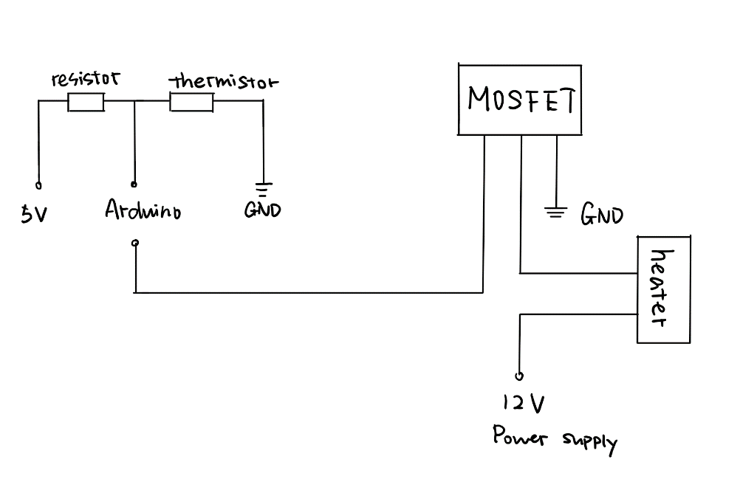

*Figure 5: Temperature overall circuit diagram*

* 1. Appendix 2 Temperature MOSFET

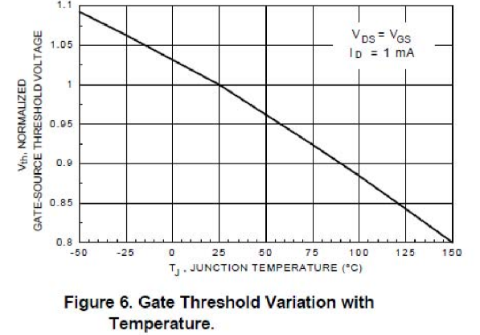

*Figure 6: Gate Threshold Variation with Temperature*

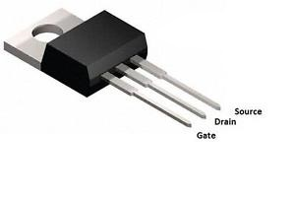

*Figure 7: MOSFET example*

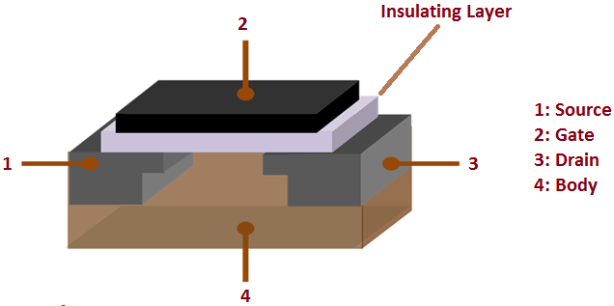

*Figure 8: MOSFET model*

* 1. 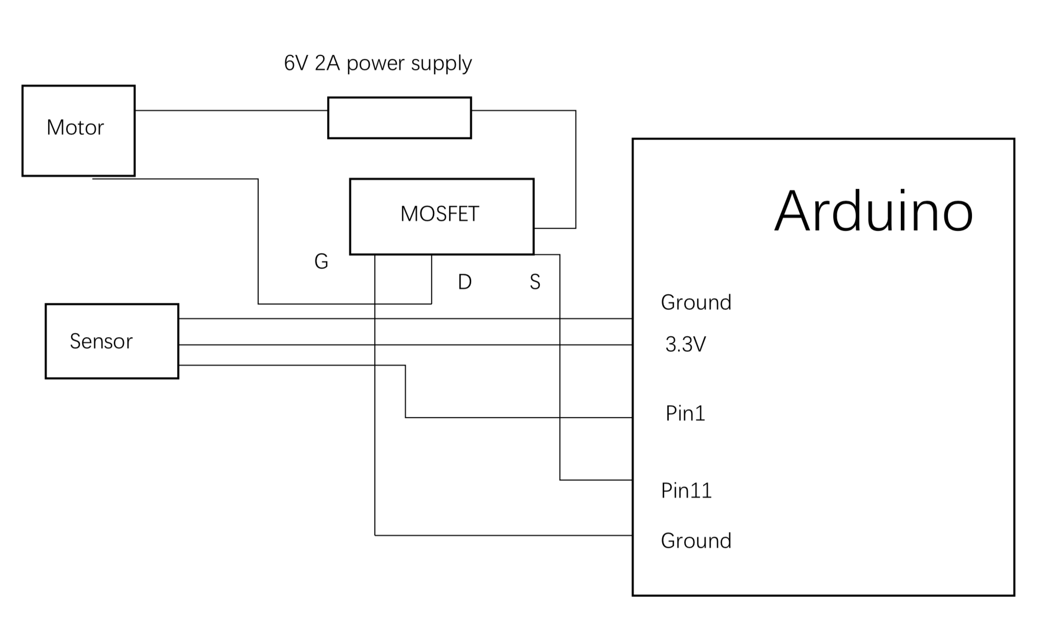Appendix 3 Stirring overall circuit

*Figure 9: Stirring overall circuit diagram*

* 1. Appendix 4

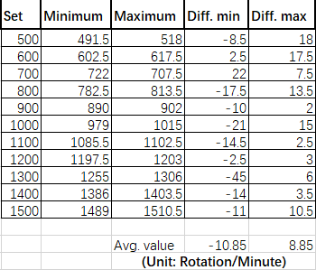

*Figure 10: Stirring overall circuit diagram*

* 1. Appendix 5

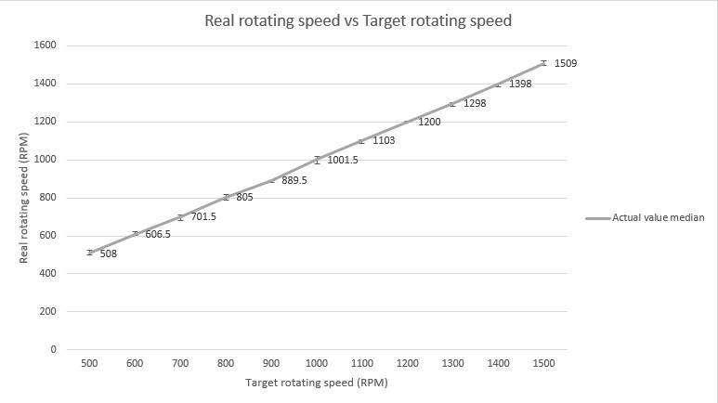

*Figure 11: Stirring overall circuit diagram*

* 1. 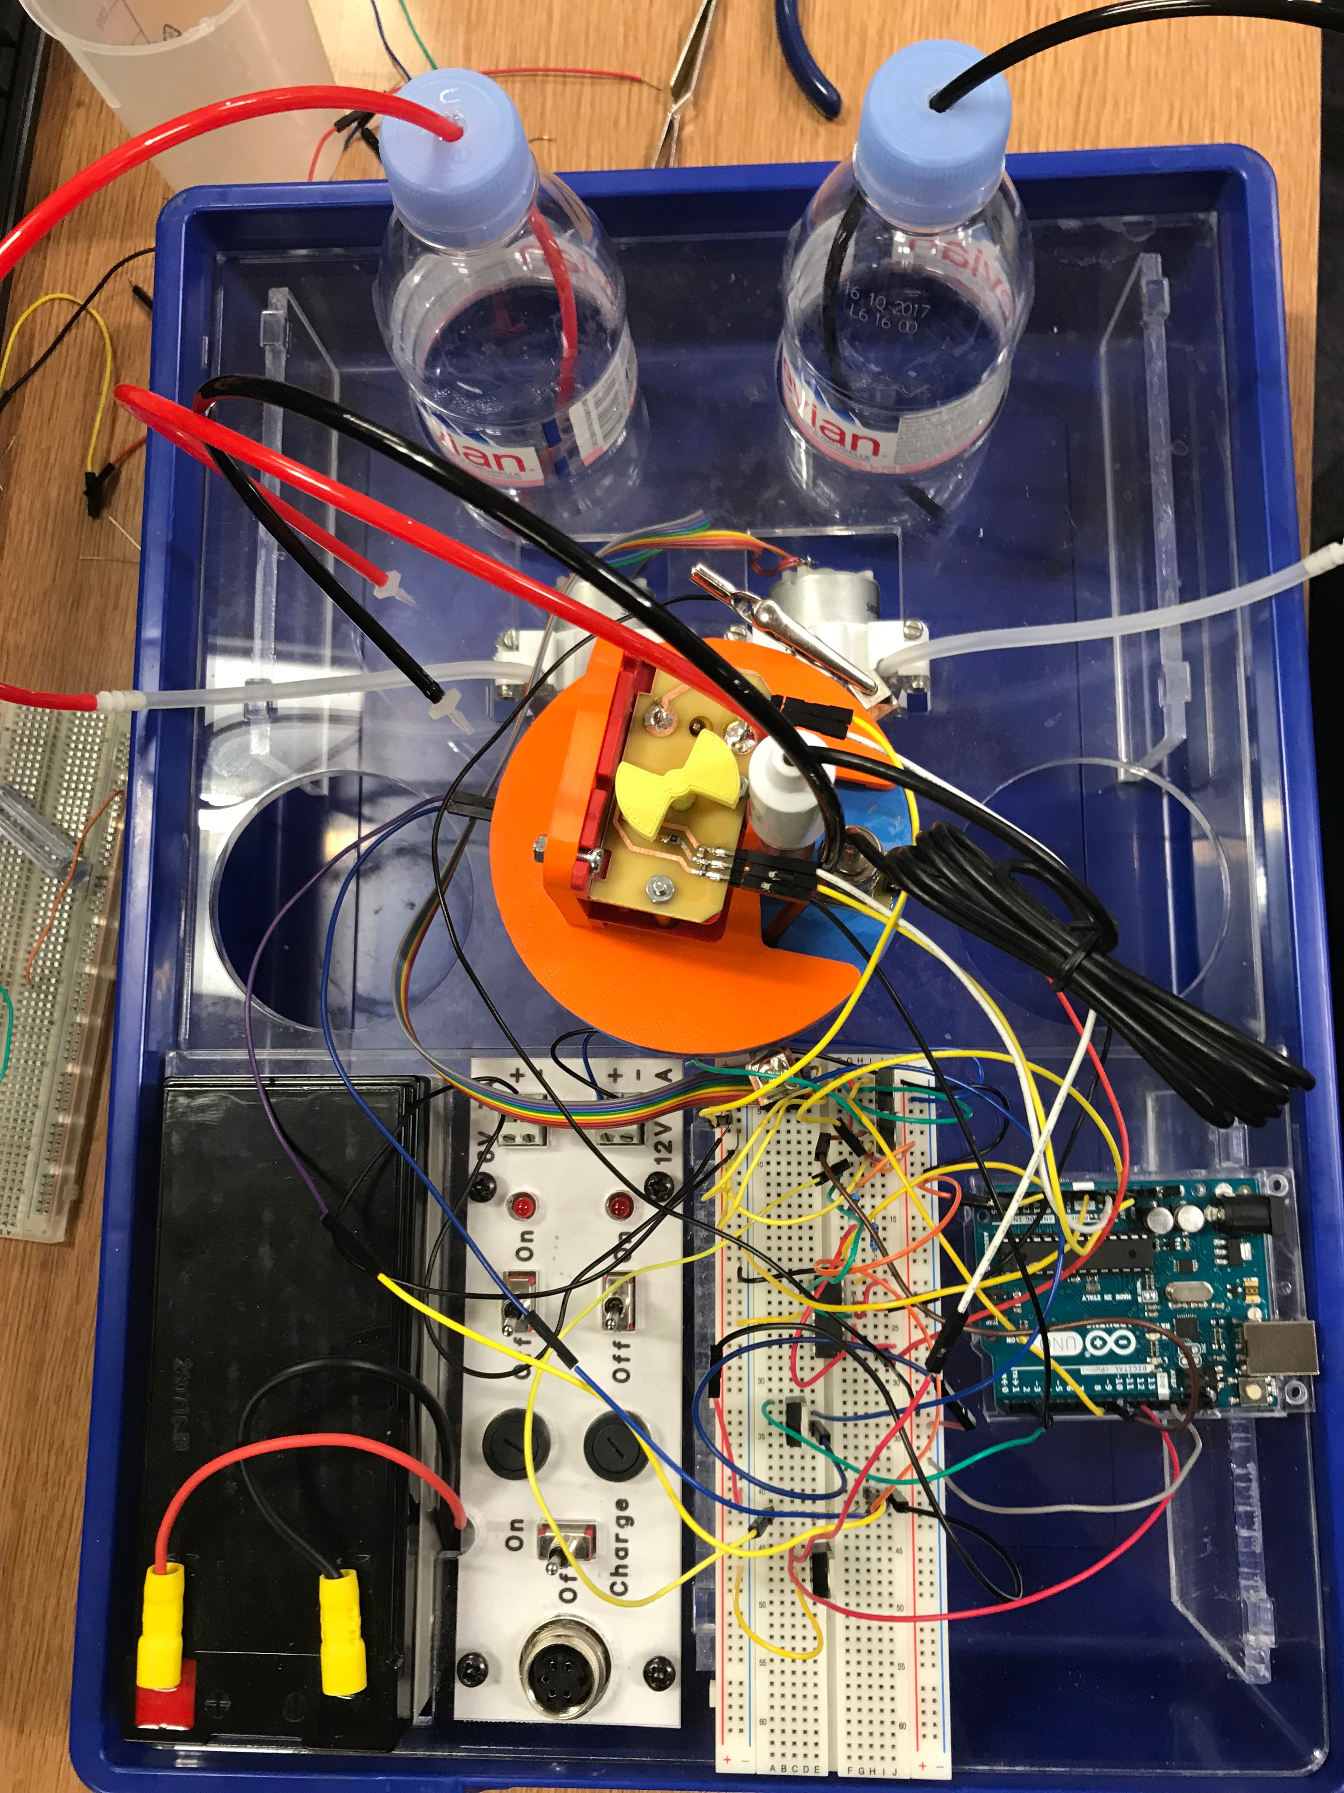Appendix 6 Prototype

*Figure 12: Prototype of the control system*

1. Reference

[1] TEXAS INSTRUMENTS (2013) Designing with pH electrodes, Available at: http://www.ti.com/lit/an/snoa529a/snoa529a.pdf (Accessed: 12th December 2018).

[2] TEXAS INSTRUMENTS (2015) LMC660 CMOS Quad Operational Amplifier, Available at: http://www.ti.com/lit/ds/symlink/lmc660.pdf (Accessed: 12th December 2018).

[3] Benn Thomsen Driving Heavy Current Loads, Available at: https://bennthomsen.wordpress.com/engineering-toolbox/ti-msp430-launchpad/driving-heavy-current-loads/ (Accessed: 12th December 2018).

[4] Matt Richardson (2018) Using a Transistor to Control High Current Loads with an Arduino, Available at: https://itp.nyu.edu/physcomp/labs/motors-and-transistors/using-a-transistor-to-control-high-current-loads-with-an-arduino/ (Accessed: 12th December 2018).

[5] TEXAS INSTRUMENTS (2013) Designing with pH electrodes, Available at: http://www.ti.com/lit/an/snoa529a/snoa529a.pdf (Accessed: 12th December 2018).

[6] “Using A Thermistor | Thermistor | Adafruit Learning System". *Learn.Adafruit.Com*, 2018, https://learn.adafruit.com/thermistor/using-a-thermistor. (Accessed 12 Dec 2018).

[7] *Farnell.Com*, 2018, http://www.farnell.com/datasheets/86133.pdf. (Accessed 12 Dec 2018).

[8] *Fairchildsemi.Com*, 2018, https://www.fairchildsemi.com/datasheets/BS/BS170.pdf. (Accessed 12 Dec 2018).

[9] "Mosfet - Google Search". *Google.Com.Hk*, 2018, https://www.google.com.hk/search?q=mosfet&source=lnms&tbm=isch&sa=X&ved=0ahUKEwjJrK__pXfAhWI6aQKHbSZDWcQ_AUIDigB&biw=1563&bih=909#imgrc=7U7U0Et2L5lccM: https://www.fairchildsemi.com/datasheets/BS/BS170.pdf. (Accessed 12 Dec 2018).

[10] Aqeel, Adnan, and G+. "Introduction To MOSFET - The Engineering Projects". *The Engineering Projects*, 2018, https://www.theengineeringprojects.com/2018/02/introduction-to-mosfet.html. (Accessed 12 Dec 2018).

[11] SHARP (2018) *GP2S700HCP,*Available at: *http://www.farnell.com/datasheets/53142.pdf* (Accessed: 9th December 2018).

[12] DYNAPER (2018) *The Driving Force: Magnetic versus Optical Encoder Engines,*Available at: *https://www.dynapar.com/technology/optical-encoders/* (Accessed: 11st December 2018).

[13] Arduino (2018) *PWM,*Available at: *https://www.arduino.cc/en/Tutorial/PWM*(Accessed: 9th December 2018).

[14] FAIRCHILD semiconductor (Oct 2003) *FDP7030BL/FDB7030BL N-Channel Logic Level PowerTrenchÒ MOSFET,*Available at: *http://www.farnell.com/datasheets/245431.pdf* (Accessed: 10th December 2018).